**Create pipeline and integrate Jenkins, Sonarqube and jfrog**

1. Go to Jenkins and create an new item

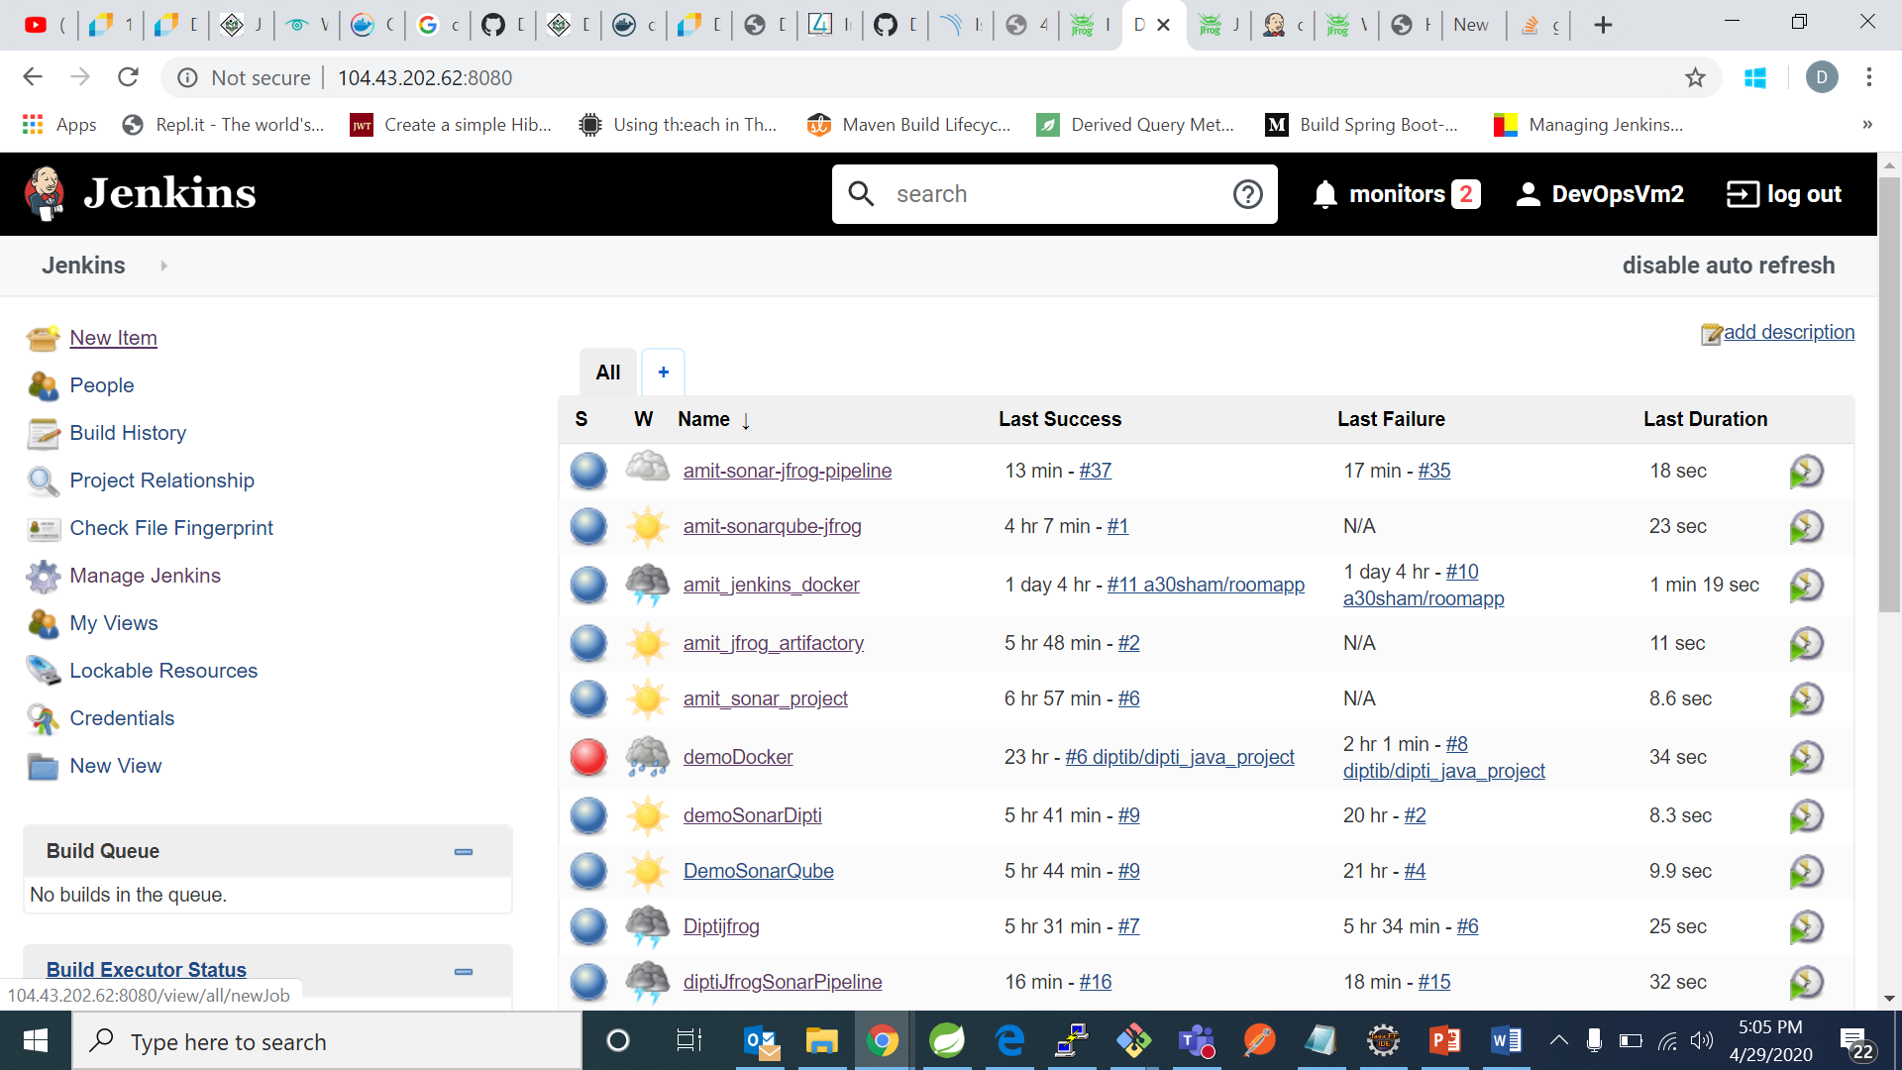

1. Now create a pipeline project:

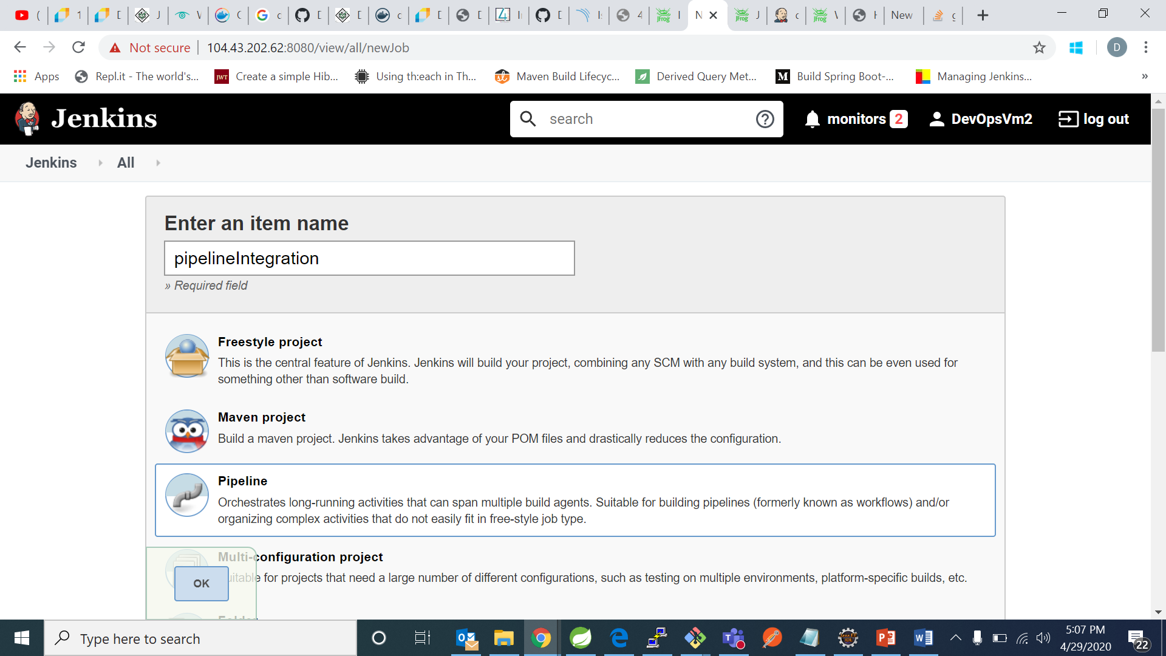

1. Go to pipeline and write the following pipeline:

pipeline{

agent any

stages{

stage('Source'){

steps{ git 'https://github.com/Diptimb/Maven-Project.git'}}

stage('Compile package'){

tools {

maven 'Maven'

}

steps{

sh 'mvn clean package' }}

stage ('upload') {

steps{

script {

def server = Artifactory.server "1"

def buildInfo = Artifactory.newBuildInfo()

buildInfo.env.capture = true

buildInfo.env.collect()

def uploadSpec = """{

"files": [ {

"pattern": "**/target/*.war",

"target": "libs-snapshot-local"}]

}"""

server.upload spec: uploadSpec, buildInfo: buildInfo

server.publishBuildInfo buildInfo

}}}

stage('Sonar Analysis'){

steps{

script {

Pipeline_Message=env.STAGE_NAME

echo "Sonar Analysis"

}

dir("/var/lib/jenkins/workspace/diptiJfrogSonarPipeline")

{

withSonarQubeEnv('sonarqube')

{

sh 'mvn sonar:sonar'

}

}

}

}

}

}

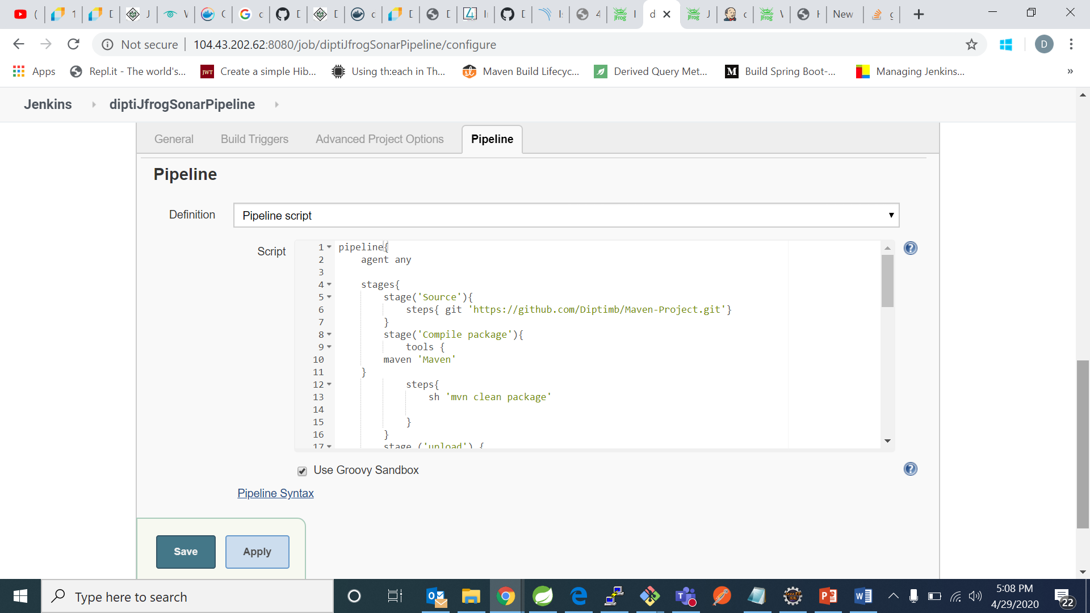

1. Click on save and click on build now

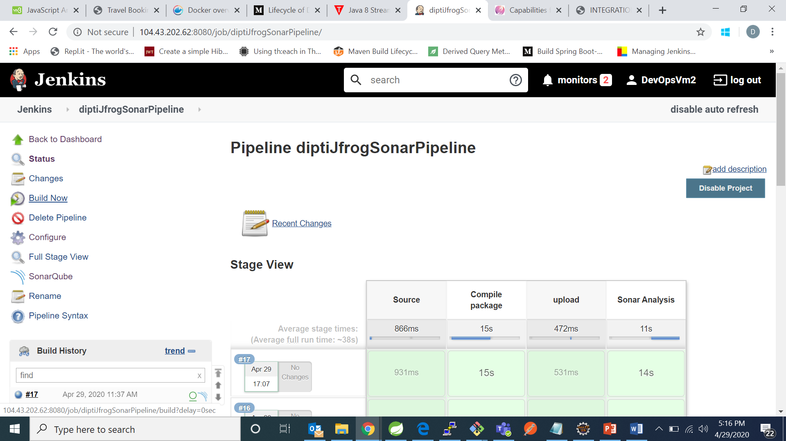

1. Now go to Sonarqube and check for your code analysis:

In my case AppRunner is the build project.

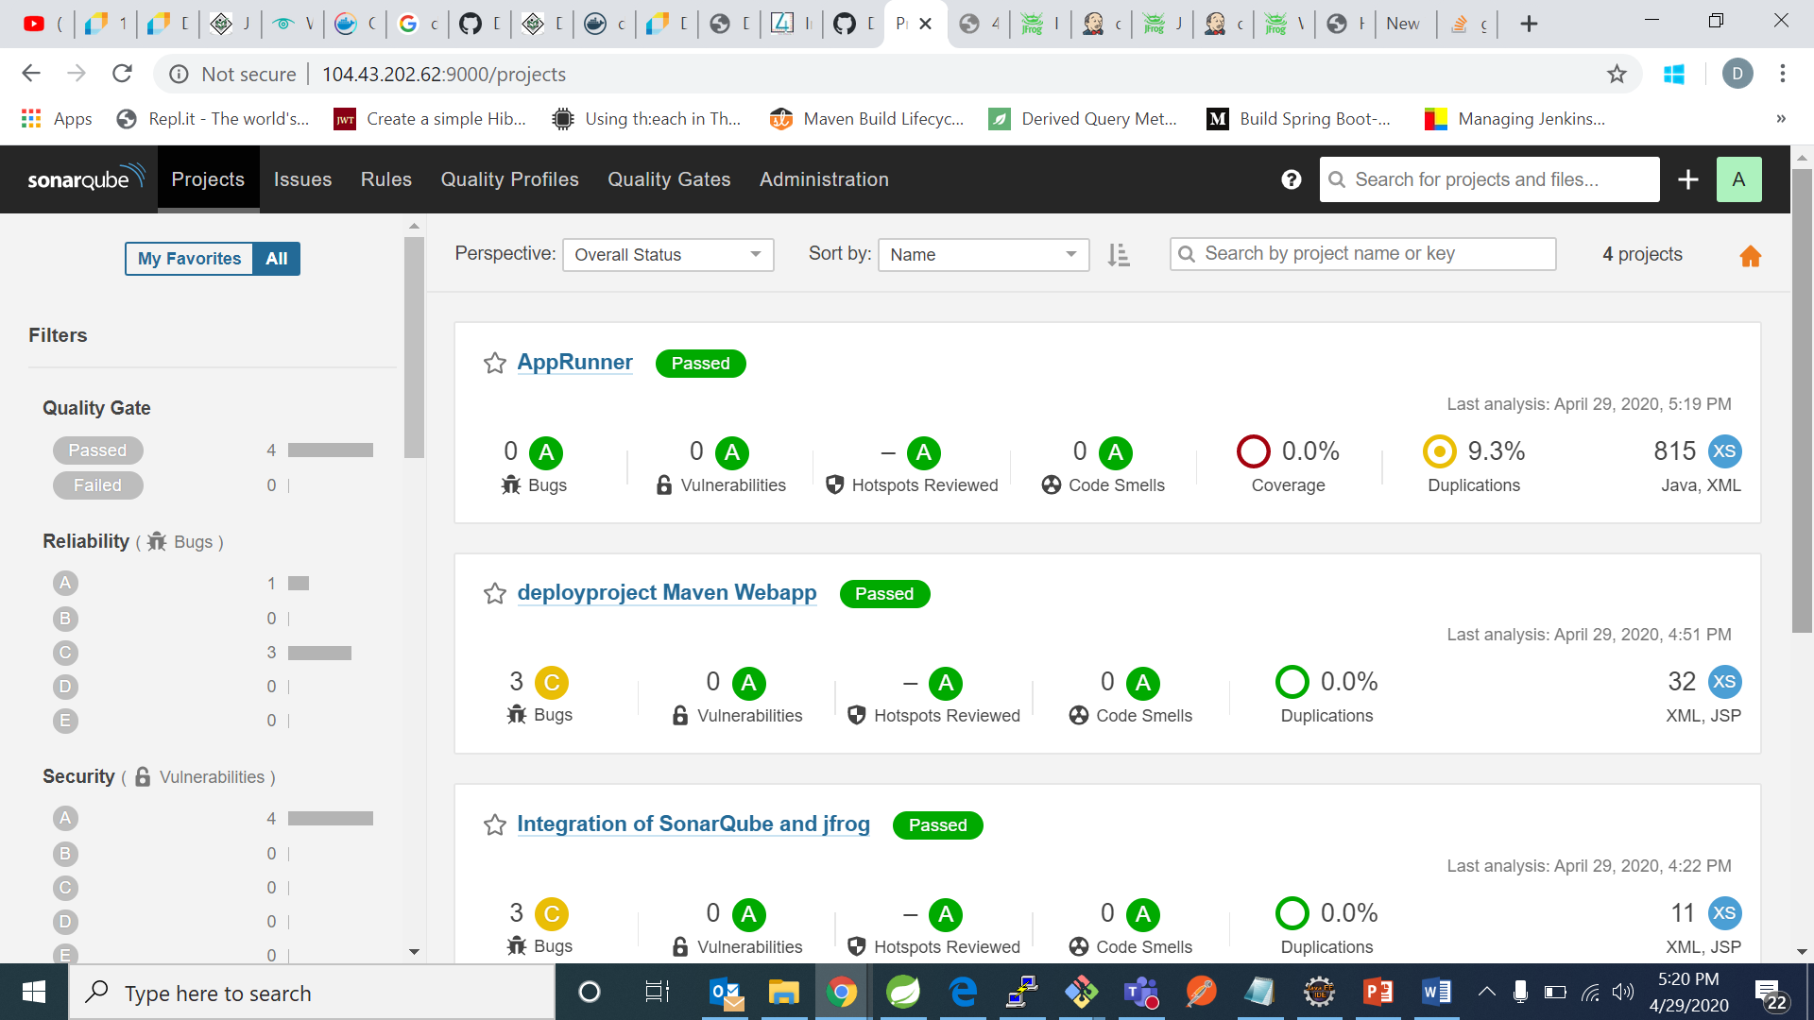

1. Now open jfrog and check for your project package.

In my case “diptijfrogSonarPipeline” is the project package.

